PRACTICAL LESSON 3

CHC 6171 - PRINCIPLES OF SECURE OPERATING SYSTEMS

Some early system call practise.
Write a small program into which you can add the following function calls and test them out. You will also need to create a small text file to read from and write to within your program.
Write the function calls for:
a) getting a file pointer for a file
b) getting a file descriptor for a file
c) formatted input
    - from the keyboard
    - from a file
d) formatted output
    - to the screen
    - to a file

Building The Minix Kernel

Before you start it is strongly recommended that you take a snapshot with VirtualBox. That way, any errors can easily be undone.
To take a snapshot, go to the “snapshots” section of your Oracle VM VirtualBox Manager and press the “take” button at the top of the screen.
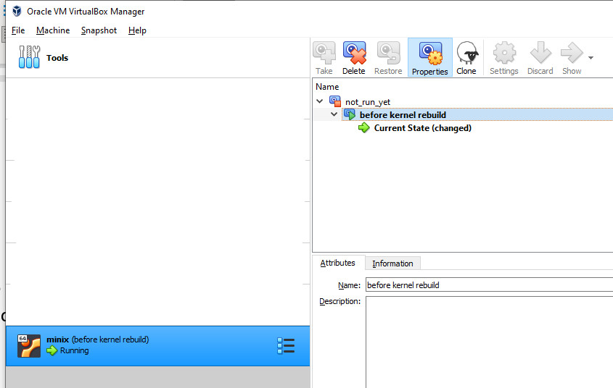

For demonstration purposes, we will make a small modification to the Minix kernel code.
The kernel code is located at “/usr/src/minix/kernel”.
Use Nano to edit the file “/usr/src/minix/kernel/main.c”:
$ nano /usr/src/minix/kernel/main.c
Make a small modification to the code, e.g. the one shown below. (This is line 348 in the unmodified code – use CRTL+_ to go straight to this line.)
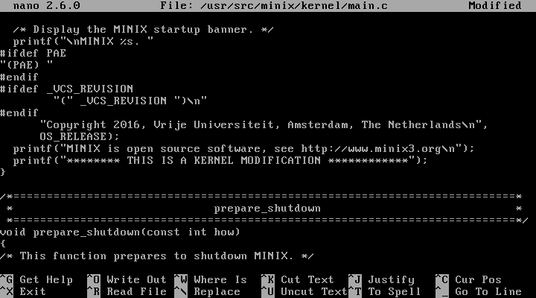
Save the modified file.
Now go to the directory “/usr/src/releasetools”.
$ cd /usr/src/releasetools
This directory contains a make file for the kernel. Type the following to rebuild the kernel:
$ make hdboot
The kernel will now rebuild. This process can take a while, particularly the first time you do it. Subsequent builds should be quicker as it should only recompile files which have been modified.
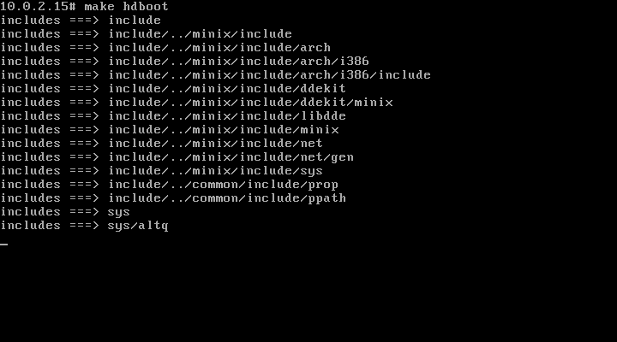

Stop the machine using the “halt” command. Power off the VM when prompted to do so.
Restart the machine and you should see your modification when the system boots.
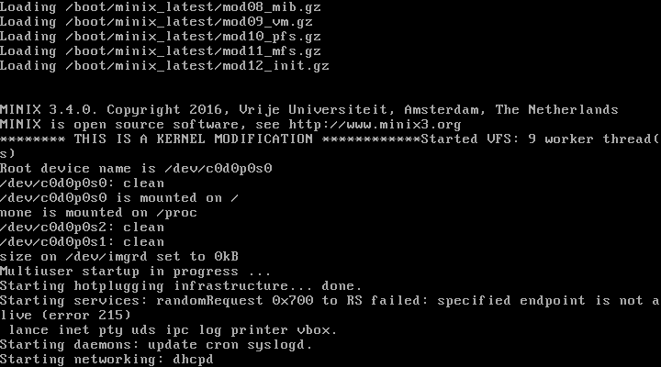
Creating a multiprocess program
- Write the following program in a new file multi.c file in Minix. You can use the nano editor in Minix or use an editor in Windows to edit the file in the shared folder. If you do use nano you will find CTRL+O is needed to save and CTRL+X to exit.
- #include <unistd.h>
- #include <stdio.h>

- void one() {
- for (int x=0; x<100; x++) {
- printf("One.");
- }
- }

- void two() {
- for (int x=0; x<100; x++) {
- printf("Two.");
- }
- }

- int main() {
- if (fork()) {
- two();
- } else {
- one();
- }
- return 0;
- }
- Compile the file from the Minix command line: clang multi.c.
- Run the program: ./a.out (for historical reasons UNIX compilers name the output executable a.out).
- Note that the "One." and "Two." messages appear in blocks together. This is because MINIX performs automatic buffering of string output by processes. To disable this buffering, edit the file again and after each of the printf lines, add: fflush(stdout). Then compile and run again and note the output.
- The MINIX process scheduler source code is in the directory /usr/src/minix/servers/sched/. CD to this directory and look at the source files, especially schedule.c, to learn how the MINIX scheduler works.

